**Principle of Database Systems: CSE 305**

# Final Project

# Dhyan Patel 109981617

# Tayo Amuneke 110967923

# Anthony Ruiz-Alatorre 111246775

View Home page



View electronics category

View shopping cart by user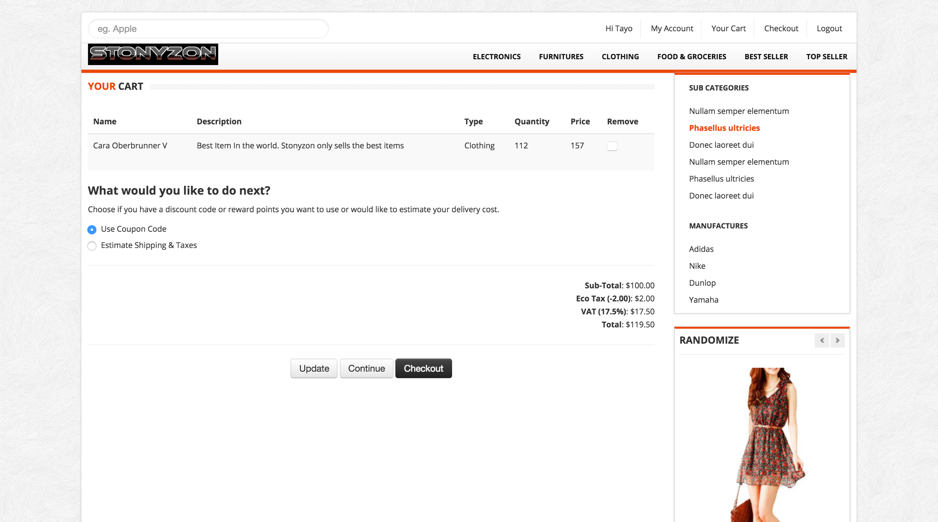

View Items by Admin

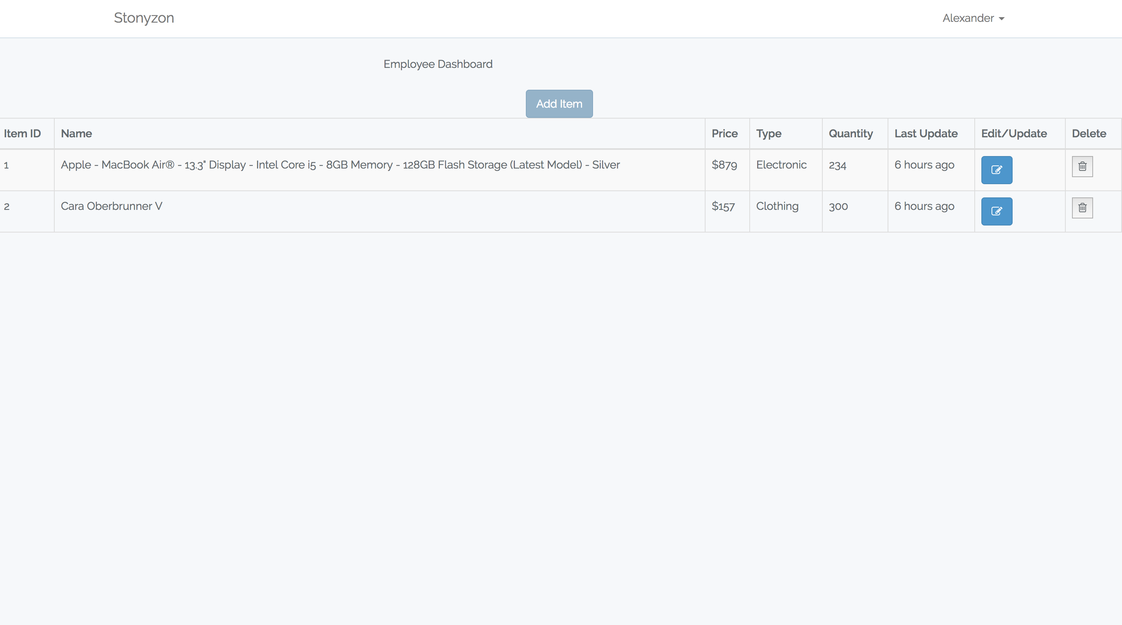

Add Item by Admin

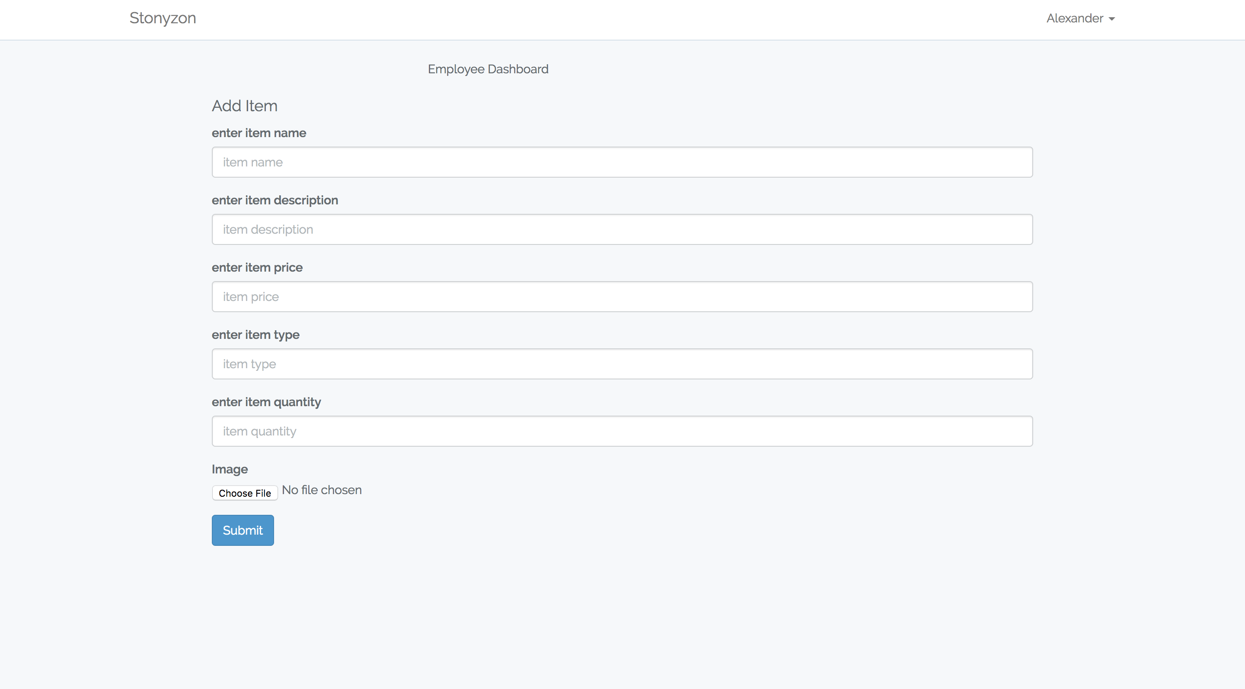

Edit Item by Admin